Questions from Dr. Avinash
- Topic: Orthographic projection and section of solids

Q1. A square prism, side of base 30 mm and axis 60 mm long, rests with its base on HP and one of its rectangular faces is inclined at 30° to VP. A section plane perpendicular to VP and inclined at 60° to HP cuts the axis of the prism at a point 20 mm from its top end. Draw section top view and true shape of section.

Sol.
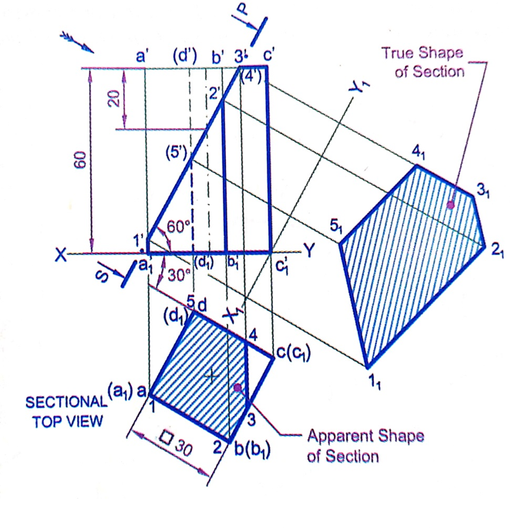

Q2. A cylinder of diameter 40 mm and height 60 mm is having its axis vertical. It is cut by a plane perpendicular to VP and inclined at 30° to HP. The plane bisects the axis of cylinder. Draw its front view, sectional top view, sectional view and true shape of section.

Sol.
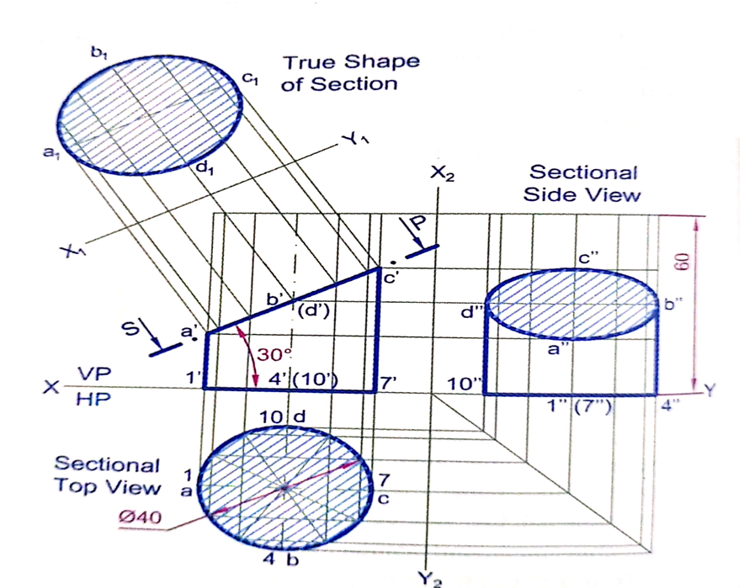

Q3. A pentagonal pyramid of side of base 25 mm and 50 mm height, rests on a traingular face on HP, with its axis parallel to VP. It is cut by a horizontal section plane, bisecting the axis. Draw the projection of retained solid.

Sol.
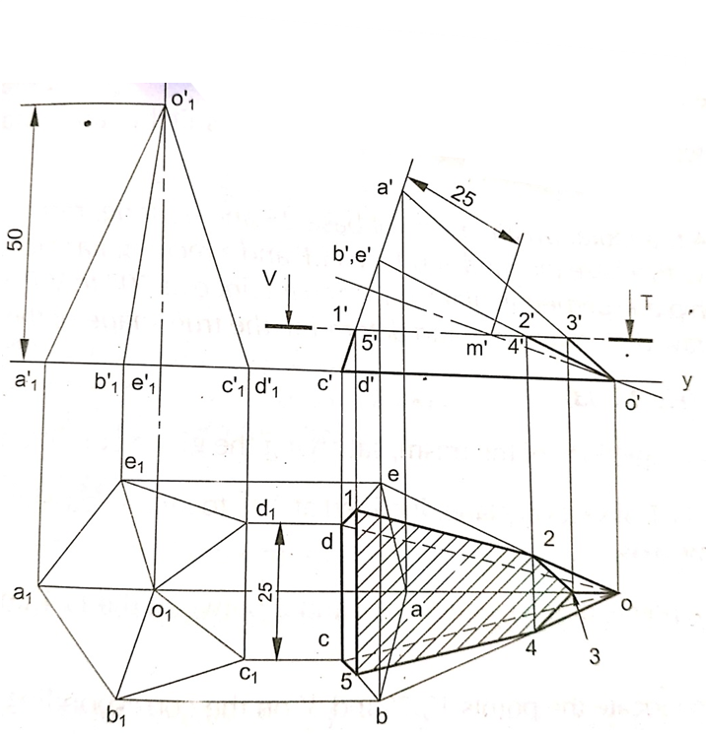

- Topic: Orthographic projection of objects

Q1. Draw the Orthographic views for engineering component given in Figure below:
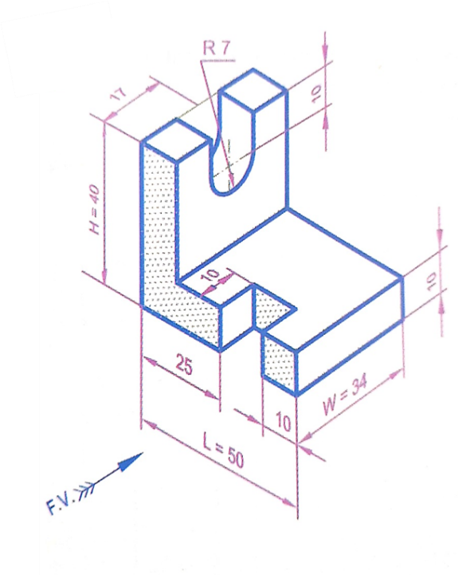
Sol.
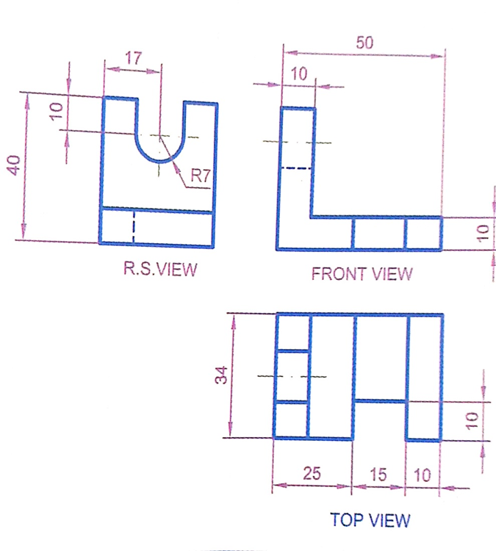

Q2. Draw the Orthographic views for engineering component given in Figure below:
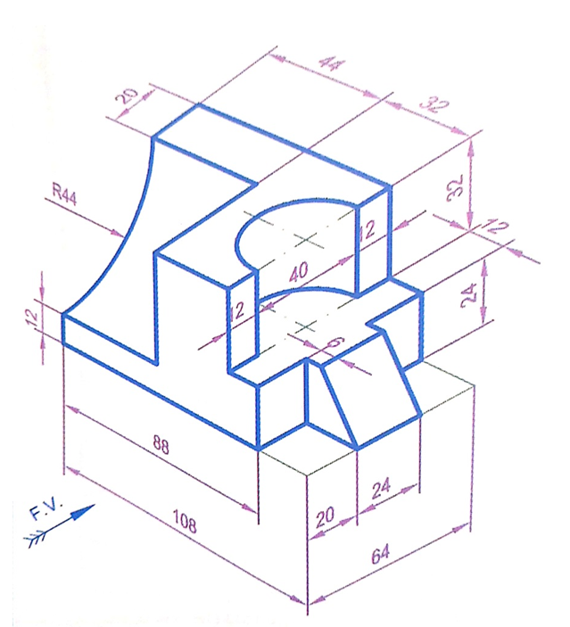

Sol.
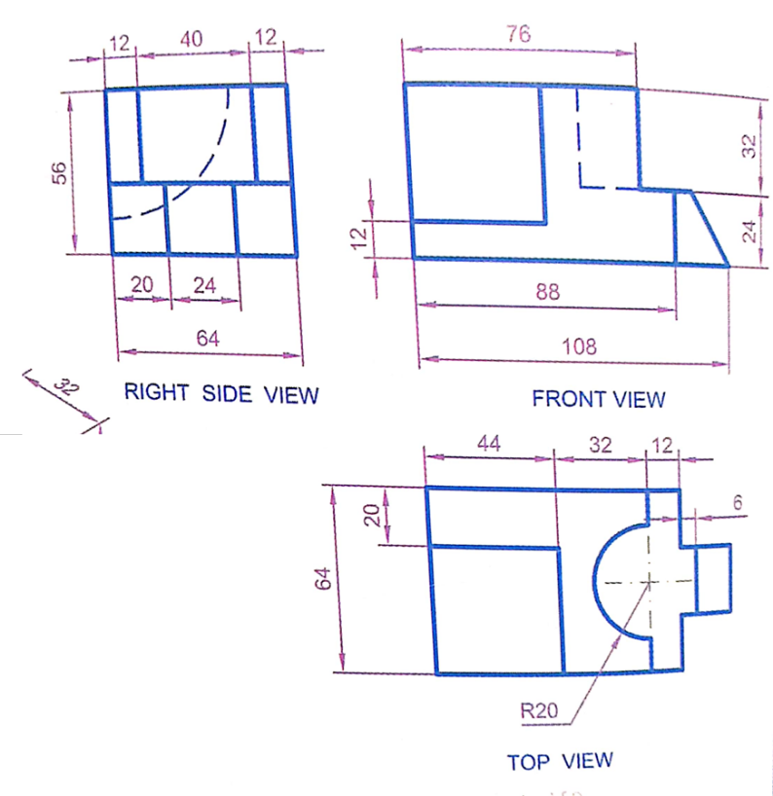

Q3. Draw the Orthographic views for engineering component given in Figure below:

Sol.

- Topic: Isometric view of objects

Q1. Draw the Isometric view for engineering component given in Figure below:
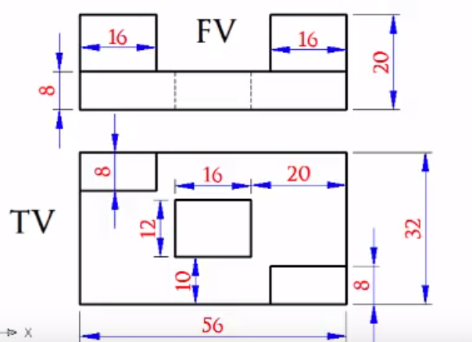

Sol.

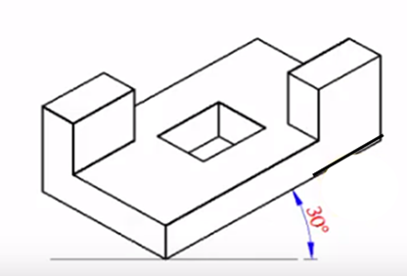

Q2. Draw the Isometric view for engineering component given in Figure below:
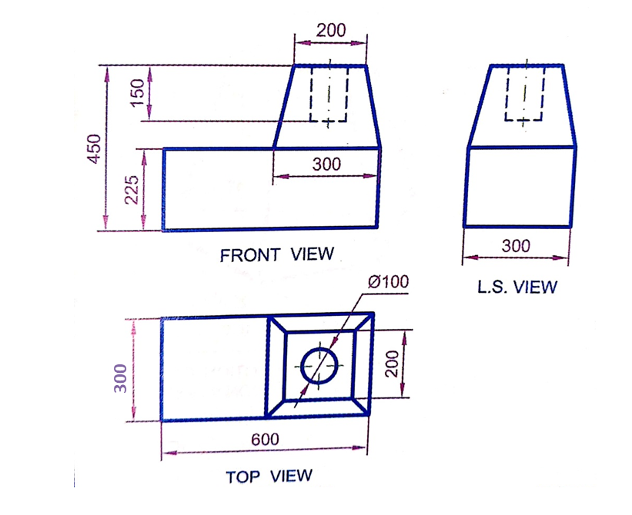

Sol.
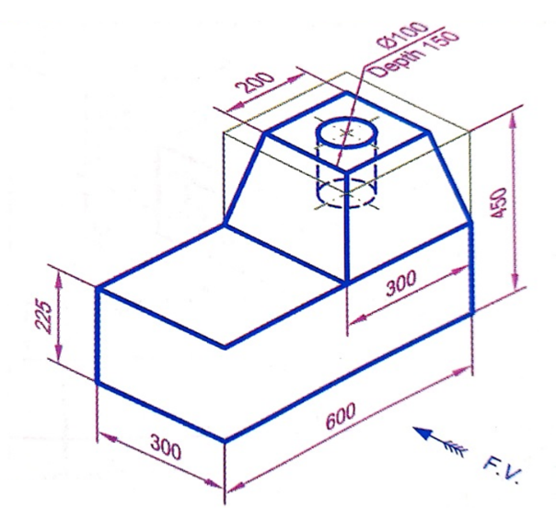

Q3. Draw the Isometric view for engineering component given in Figure below:
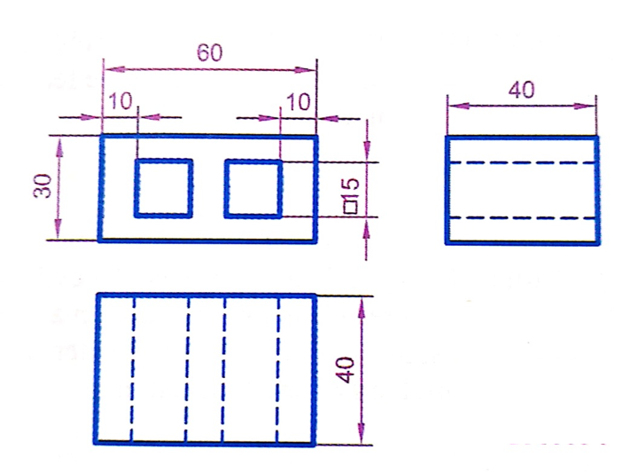

Sol.
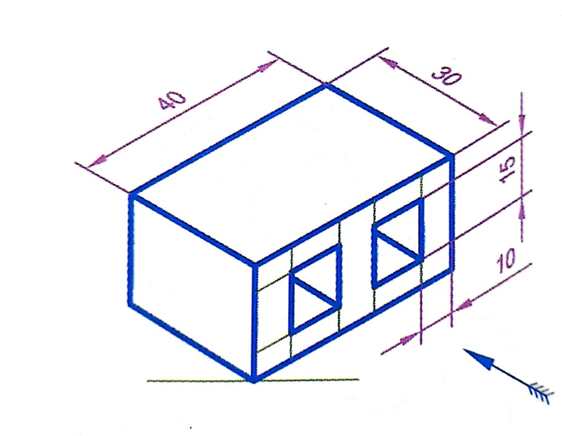

- Topic: Intersection of solids/Development of surfaces

Q1. A regular pentagonal pyramid of side of base 30 mm and height 60 mm is resting vertically on its base on HP such that two sides of the base are perpendicular to VP. It is cut by a plane inclined at 60° to HP and perpendicular to VP. The cutting plane bisects the axis of the pyramid. Obtain the development of lateral surface of the truncated pyramid.
Sol.

Q2. A vertical hexagonal pyramid of side of base 25 mm and altitude of 60 mm rests with a base edge parallel to VP and nearer to it. It is cut by two planes perpendicular to VP. One is horizontal and cuts the portion of the pyramid on the left of the axis at a height of 25 mm above the base pyramid. The other plane inclined at 60° to HP cuts the portion of the pyramid to the right of the axis passing through a point on it 25 mm above the base and leans upwards.
Sol.

Q3. A cylinder of 60 mm diameter and axis 80 mm long stand with its base on HP. It is completely penetrated by a square prism of 30 mm side and 100 mm length, the axis of which is parallel to both the reference planes and the faces equally inclined to HP. The axes of solids intersect at right angles. The height of the axis of the prism above HP is 40 mm. Draw the projections the solids showing the curves of intersection in the front view.
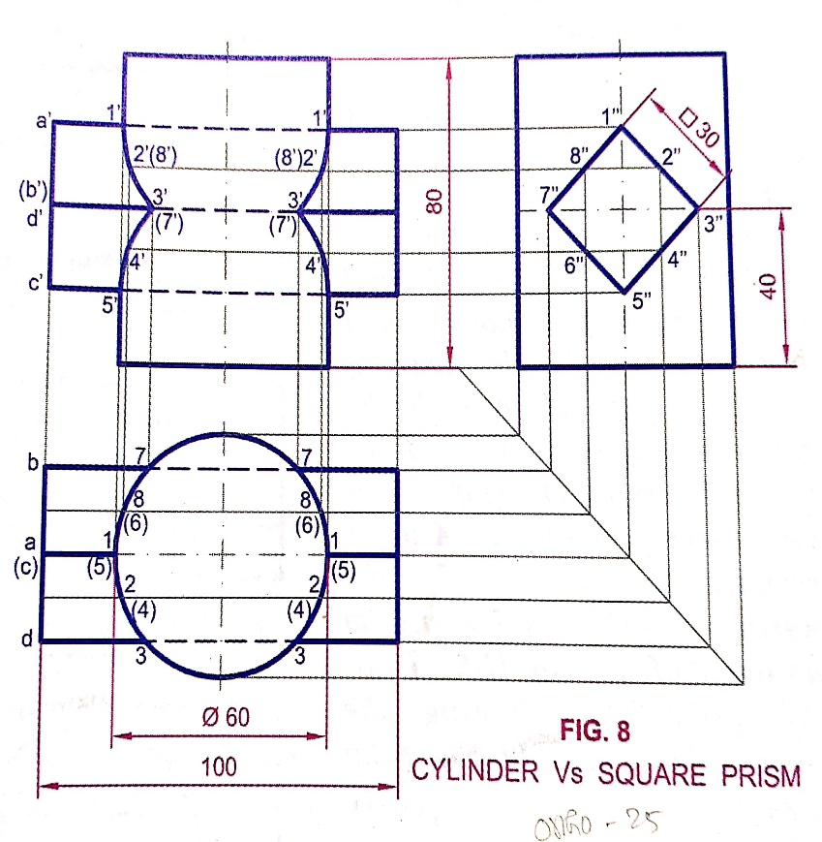
Sol.

